Integrating the Healthcare Enterprise



IHE Patient Care Coordination (PCC)

Technical Framework Supplement

Cross Enterprise Basic eReferral
Workflow Definition Profile
(XBeR_WD)

< Public Comment or
Trial Implementation>

Date: <June XX, 20XX>
Author: Mauro Zanardini, Arianna Cocchiglia

Email: mzanardini@consorzioarsenal.it, acocchiglia@consorzioarsenal.it

Introduction

This supplement is written for Trial Implementation. It is written as changes to the documents listed below. The reader should have already read and understood these documents:
- PCC Technical Framework Volume 1, Revision 5.0
- PCC Technical Framework Volume 2, Revision 5.0
This supplement also references other documents. The reader should have already read and understood these documents:
- IT Infrastructure Technical Framework Volume 1, Revision 6.0
- IT Infrastructure Technical Framework Volume 2, Revision 6.0
- IT Infrastructure Technical Framework Volume 3, Revision 6.0
- The Patient Identifier Cross-Reference (PIX) and Patient Demographic Query (PDQ) HL7 v3 Supplement to the IT Infrastructure Technical Framework.
- HL7 and other standards documents referenced in Volume 1 and Volume 2
- Dilbert 2.0: 20 Years of Dilbert by Scott Adams, ISBN-10: 0740777351, ISBN-13: 978-0740777356

Open Issues and Questions
< No specific guidance>

Closed Issues
< No specific guidance>

Volume 1 – Profiles

X <XBeR-WD> Profile

The Cross Enterprise Basic eReferral Workflow Definition profile born as development of the ITI Cross Enterprise Document Workflow (XDW) profile to manage the workflow related to an eReferral.
The management of the workflow related to clinical process has becoming a fundamental topic with the increasing of the use by different sectors of document sharing related IHE profiles with their different types of document and information. IHE ITI has approved in Trial Implementation the Cross-Enterprise Document Workflow profile but the work done by ITI has been on the definition of the technical structure to manage a clinical workflow and not on the definition of the clinical processes, work left to the different domain.
The Cross Enterprise Basic eReferral Workflow Definition Profile defines the workflow related to the eReferral. This workflow is involved in many clinical and organizational processes for its important role in the process of digitalization. The definition of a workflow with fix rules and task is needed in a scenario cross enterprise in which many actors are involved in the same process.

X.1 Purpose and Scope

The management of the workflow related to clinical process has becoming a fundamental topic with the increasing of the use by different sectors of document sharing related IHE profiles with their different types of document and information.
This profile proposal is born as development of the ITI XDW profile to manage the Cross Enterprise Basic eReferral Workflow. The management of the workflow related to the eReferral is involved in many clinical and organizational processes for its important role in the process of digitalization. The lack of a workflow management, at the moment, blocks the use of the eReferral in an extended way. The eReferral, without an instrument to manage its workflow, is only an order without any information about the status of the order itself. The definition of a workflow with fix rules and task is needed in a scenario cross enterprise in which many actors are involved in the same process.
The creation of an eReferral by a GP opens a clinical process that involves many actors and that is a cross-enterprise workflow. The purpose of the XBeR-WD profile is exactly define the workflow associated with an eReferral Document, the actors involved and the digital documents related with this process (produced in this process or produced in other clinical processes but interesting also in this one)

X.2 Process Flow

In the basic workflow pathway the patient attends a consultation to his GP for an health problem. The practitioner examines him and some of his reports in relation with his health problem. After the visit the practitioner prescribes an exam.
The workflow connected to these organizational and clinical actions is composed by four steps:
- a physician refers a patient to another healthcare provider for a specialist’s consultation;
- the HCP, from the Hospital Information System, schedules the visit;
- the HIS admits the patient in hospital and the specialist can start the consultation which may span one or more visits;
- the specialist completes the consultation and produces a report;
These steps can be tracked in 3 different tasks of the workflow, (figure X.2-1):

-Referral Requested: that tracks step A, performed by the Requester of the visit
-Referral Scheduled: that tracks step B, performed by the Scheduler of the visit
-Referral Referred: that tracks steps C and D, performed by the HCP and the specialist

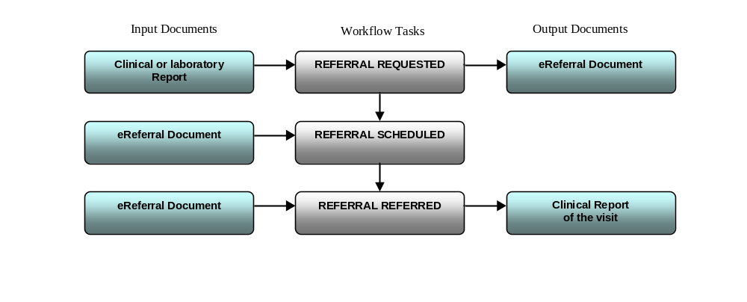 Figure X.2-1: task involved in the eReferral process

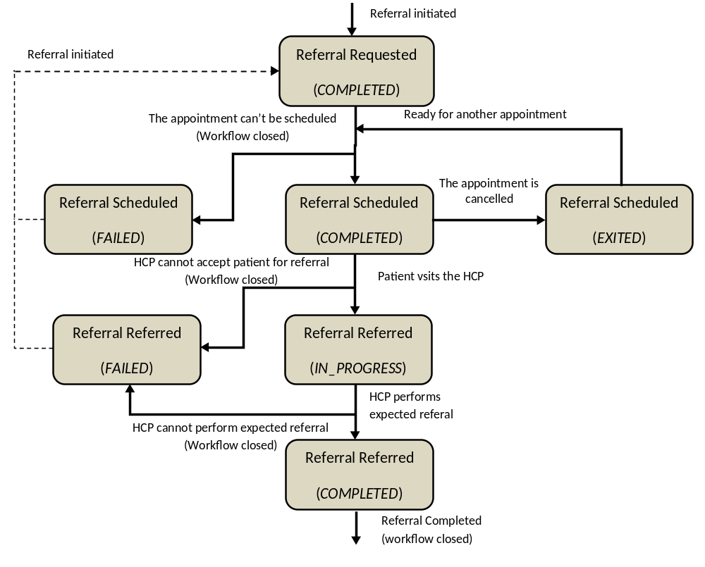

Figure X.2-2. XBeR Workflow Definition complete process flow

Table below (Table X.2-1) lists the various documents that shall, or may be referenced as either input or output documents for each task/stsatus pair defined by the XBeR-WD profile.

Task Name | Task Status | Input Docs | Option | Output Docs | Option
Referral Requested | Completed | Clinical Report | O | eReferral | R
Referral Scheduled | Completed | eReferral | R | N/A | -
Referral Scheduled | Exited | N/A | - | N/A | -
Referral Scheduled | Failed | N/A | O | Failure Report | R
Referral Referred | In progress | eReferral | R | N/A | -
Referral Referred | Completed | eReferral | R | Clinical Report | R
Referral Referred | Failed | N/A | - | Failure Report | R
Table X.2-1: Documents referenced for each task/status pair

X.3 Actors

In this section we present the Workflow actors involved in the eReferral process and, using the figure X.3-1, we describe in detail process transactions and interactions between them.

Workflow  Actors | Description
Referral Requester | Health Professional (e.g. GP) that initiates the referral workflow. Produces the eReferral and the related supporting document.
Referral Scheduler | Actor responsible for the scheduling of the referral, by providing an appointment for the patient
Referral Performer | Actor responsible for execution of the visit. This workflow actor encapsulate many entities within the enterprise that responds to the referral request and produce the clinical report of the visit ending the eReferral process
Workflow Monitor | Actor that tracks progress of the workflow and reacts to certain exception conditions. This actor can be satndalone or grouped with one of the above Workflow Actors

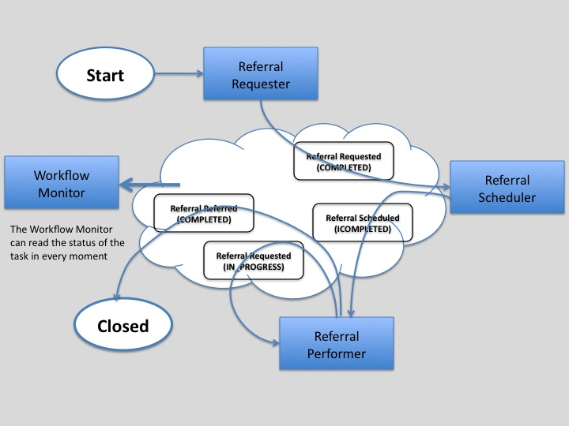

Figure X.3-1 Process transaction between workflow actors

X.3.1 Use Cases

In this section we present the detailed use-case of reference. In the first part of this section (subsection X.3.1.1) we present the detailed chronological sequence of steps involved in the simplest process flow, without failing situations or scheduling cancellation. In the second one (subsection X.3.1.2) we present potential exception situations and the scheduling cancellation phase.

X.3.1.1 Basic process flow
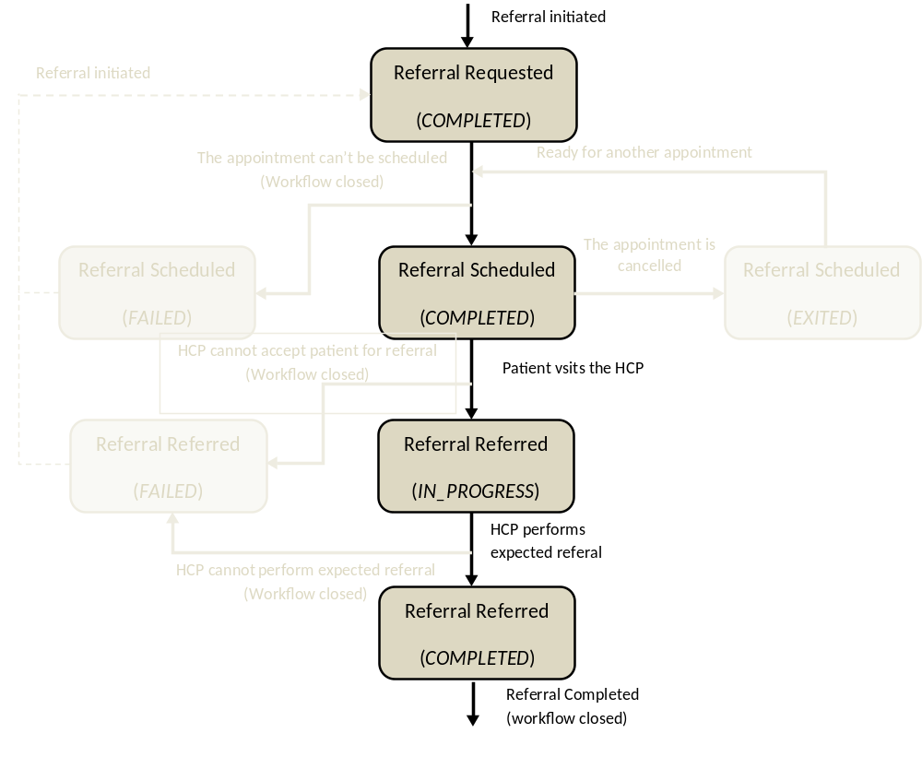
- A physician refers a patient to another healthcare provider for a specialist’s consultation
In this task the GP examines the patient and reviews the patient’s most recent laboratory reports. The GP refers the patient to a specialist, creating an eReferral Document and referencing the laboratory reports.
The GP’s software, as a Referral Requester , produces the eReferral Document and one Workflow Document to track the clinical workflow of the eReferral. As shown in column A of Figure X.3.1.1-1, at this moment the Workflow Document created has only one task (“Referral Requested”) characterized by:
- a task status “COMPLETED”
- the references to the laboratory report analyzed by the GP as inputs of the task
- the reference to the eReferral document produced as outputs of the task.
In order to share documents that are produced during the task, the Referral Requester submits the eReferral Document and the Workflow Document to the XDS Document Repository (for technical details see vol.2 Figure X.6.3-1).

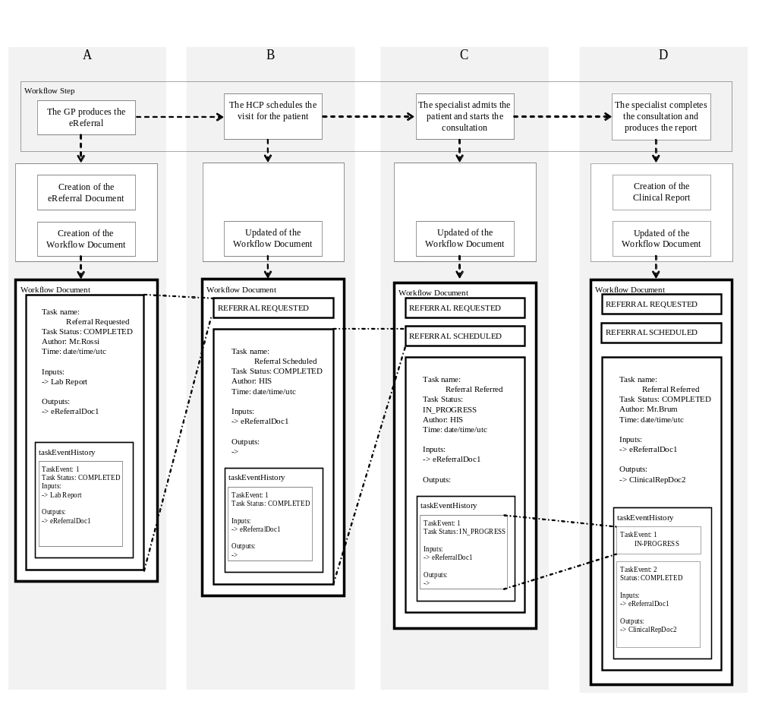
Figure X.3.1.1-1. Management of the Workflow Document in a basic process flow

From this moment the eReferral is available to a wide range of care providers.

B. The HCP, from the Hospital Information System, schedules the visit

The patient can call or go to healthcare provider of his choice (or suggested by the GP) to schedule the exam.
During this step the HCP, as a Referral Scheduler , checks in which step the eReferral is and he schedules the visit. Once the visit has been scheduled, the Referral Scheduler updates the Workflow Document to track that the visit has been scheduled. As shown in column B of Figure X.3.1.1-1, at this step of the workflow, the Workflow Document is updated with a new version in which a new task “Referral Scheduled” is added to the content of the previous version of the Workflow Document.
The task “Referral Scheduled” is characterized by:
- a task status “COMPLETED”
- the references to the eReferral document produced by the GP as inputs of the task.
The Referral Scheduler ,provides the updated version of Workflow Document to the XDS Document Repository/Registry through a Replace of the previous version of the Workflow Document (for technical details see vol.2 Figure X.6.3-1). From this moment no other HCP can schedule the same visit.

C. The HIS admits the patient in hospital the day of the visit and the specialist can start the visit
After a few days the patient is admitted at the hospital. During this task, the HCP, as a Referral Performer, consults the eReferral and the Workflow Document related to understand the task that needs to be performed and the process of the visit can start.
The Referral Performer accesses the document by using his software, and an XDS Document Consumer, to query and retrieve the Workflow Document and the eReferral document, to check the reservation (for technical details see vol.2 Figure X.6.3-1).
As shown in column C of Figure X.3.1.1-1, at this step of the workflow, the Workflow Document is updated with a new version in which a new task “Referral Referred” is added to the content of the previous version of the Workflow Document. The task “Referral Referred” is characterized by:
- a task status “IN_PROGRESS”
- the references to the eReferral document produced by the GP as inputs of the task.
The Referral Performer provides the updated version of Workflow Document to the XDS Document Repository/Registry through a Replace of the previous version of the Workflow Document (for technical details see vol.2 Figure X.6.3-1).
From now the Workflow Document and the eReferral document are available for the specialist.

D. The specialist completes the consultation and produces a report
The specialist performs the visit and, at the end of the consultation the specialist’s software, as a Referral Performer, produces a report of the consultation itself and he terminates the visit process.
In this task, the Referral Performer, updates the Workflow Document changing the status of the “referred” task.
As shown in column D of the Figure X.3.1.1-1 the Workflow Document, the “Referral Referred” task is characterized by:
- a task status “COMPLETED”
- the references to the eReferral document produced by the GP (the laboratory report was not used by the specialist) as inputs of the task
- the references to the report of the consultation as output of the task
The history of the changes of status of the task is tracked inside the task as a list called taskEventHistory.
The Referral Performer provides the updated version of Workflow Document to the Document Repository through a replace of the previous version of the Workflow Document (for technical details see vol.2 Figure X.6.3-1).

At any time the Referral Requester may review the Workflow Document and the new documents produced related to this workflow. This is accomplished through a query and retrieve by the GP’s software of the active Workflow Document from the XDS Document Registry and the XDS Document Repository. Although not shown in this use case, it would also be possible to manage a system of subscription and notification to communicate the progress between the different steps through the use of the Document Metadata Subscription (DSUB) profile or the Notification of Document Availability (NAV) profile.

X.2.2.2 Failing siutations

We can consider three different failing situations which may arise during this eReferral Workflow :

Bf. Failing of the scheduling process
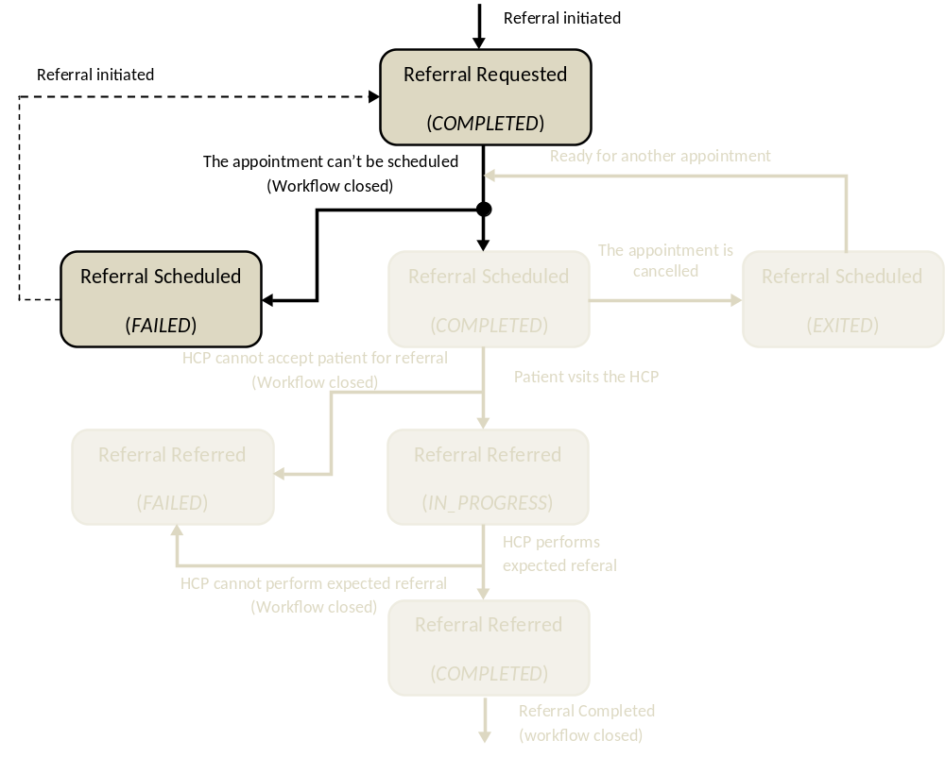
In the first case, the patient cannot schedule his specialistic consultation, because there is some problem or inconsitencies in the eReferral document. So in this phase the Hospital Information System, as Referral Scheduler , query and retrieve the eReferral Document and the Workflow Document related, to check the status of the eReferral and potential errors connected to the scheduling process. If the Referral Scheduler finds any problems, the scheduling phase fails and the eReferral Workflow is closed. The Workflow Monior, produces a report for the exception and updates the Workflow Document adding a new task named “Referral Scheduled” which is caracterized by:
- task status is “FAILED”
- the reference to the eReferral document as inputs of the task
- the reference to a report which contains reasons of the exception as outputs of the task
After updating the Worflow Monitor submits the newer version of the Workflow Document to the Document Repository/Registry. This event shall be notified to the Referral Requester. This eReferral process is closed (changing the workflowStatus of the Workflow document in status “CLOSED”) and, if necessary, another new process is started by the Referral Requester producing the second eReferral document and the second Workflow Document to track the new correct process. In this case the Workflow Document that tracks the second eReferral contains only one task named “Referral Requested” which is characterized by:
- task status is “COMPLETED”
- as inputs of the task the references to :
-the Laboratory Report
-the folderID that characterize the previous eReferral process failed
-the Exception Report
- the references to the eReferral document produced as outputs of the task.

For further technical details see vol.2 section 6.4.1, Figure 6.4.1-1

Cf. Failing of the reception phase

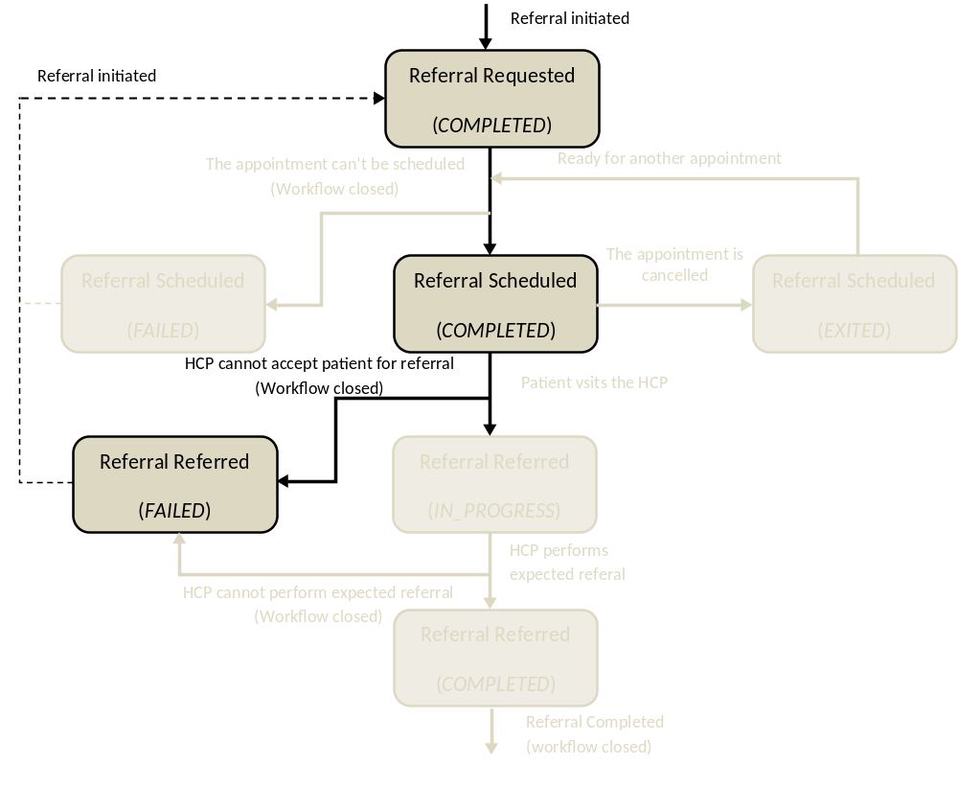
In the second case, when the Referral Performer checks the reservation of the patient he finds some problems, and cannot accept the patient into the hospital. In this case the Workflow Monitor updates the Workflow Document adding a new task named “Referral Referred” which is characterized by:
- task status “FAILED”
- the references to the eReferral produced by the GP as inputs of the task
- a report that describes the reason for the exception of the task as outputs of the task
The previous version of the Workflow Document is replaced by the new one. This event shall be notified to the Referral Requester. This eReferral process is closed (changing the workflowStatus of the WF document in status “CLOSED”) and, if necessary, another new process is started by the Referral Requester producing the second eReferral document and the second Workflow Document to track the new process. In this case the Workflow Document that tracks the second eReferral contains only one task named “Referral Requested” which is characterized by:
- task status is “COMPLETED”
- as inputs of the task the references to :
-the Laboratory Report
-the folderID that characterize the previous eReferral process failed
-the Exception Report
- the references to the eReferral document produced as outputs of the task.

For further technical details see vol.2 section 6.4.2, Figure 6.4.2-1

Df. Failing of the visit
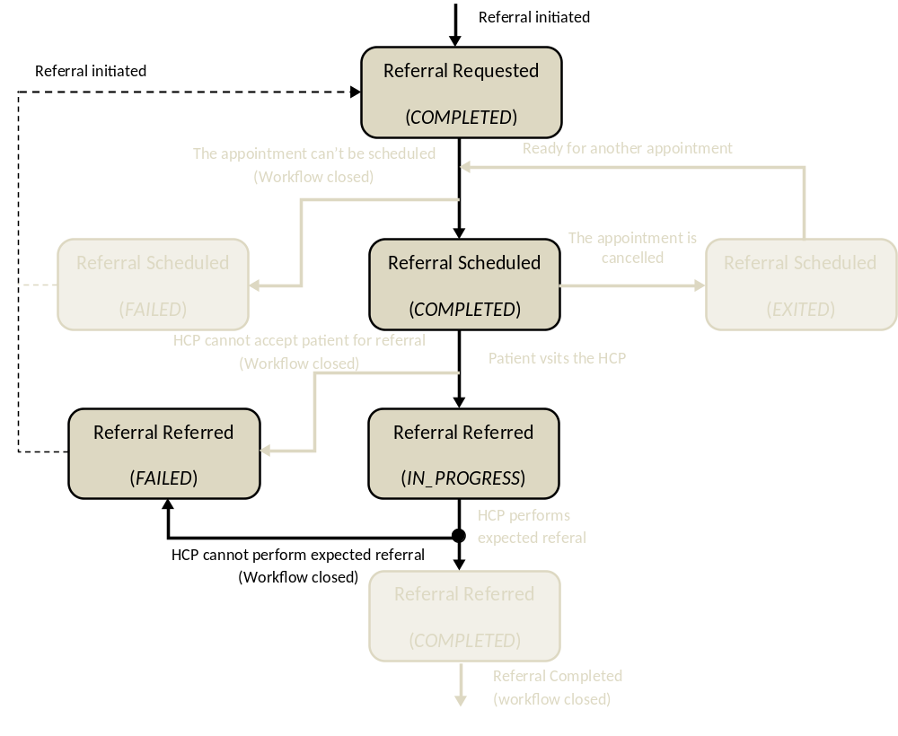
In the third case the patient is admitted in hospital to perform the visit but, once the specialist sees all the information related to the clinical process, he decides that the visit can’t be performed. In this case the Referral Performer updates the Workflow Document adding to the task named “Referral Referred” a new TaskEvent. At this moment the “Referral Referred” task is characterized by:
- task status “FAILED”
- the references to the eReferral document as inputs of the task
- the references to a report which contain reasons of the exception as outputs of the task
After updating the Referral Performer submits the newer version of the workflow Document to the Document Repository/Registry. This event shall be notified to the GP. This eReferral process is closed (changing the WorkflowStaus of the WF document in status “CLOSED”) and, if necessary, another new process starts producing the second eReferral document and the second Workflow Document to track the new correct process started by the Referral Requester. In this case the Workflow Document that tracks the second eReferral contains only one task named “Referral Requested” which is characterized by :
- task status is “COMPLETED”
- as inputs of the task the references to :
-the Laboratory Report
-the folderID that characterize the previous eReferral process failed
-the Exception Report
- the references to the eReferral document produced as outputs of the task

For further technical details see vol.2 section 6.4.3, Figure 6.4.3-1

BA. Scheduling cancellation process
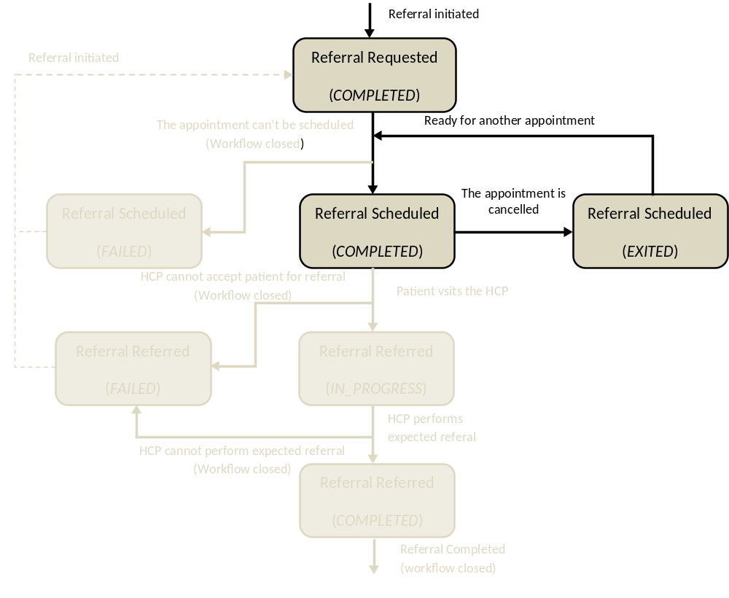

We can consider the situation in which it’s necessary to cancel the visit and make the eReferral available again for another scheduling step.
The Referral Scheduler queries and retrieves the Workflow Document to check the status of the eReferral document related. A visit has already been scheduled (Referral Scheduled task in status=COMPLETED), so, in this situation, it isn’t possible to schedule another visit. The reception phase hasn’t already been performed but the eReferral process is still in-progress (WorkflowStatus of the Workflow Document “OPEN”). In this situation the Referral scheduler shall act on the Referral Scheduled task, adding a new taskEvent that tracks the information that the scheduled visit is cancelled, in order to make the eReferral document available for another scheduling phase. The task Referral Scheduled is characterized by:
- a task status “EXITED”
No inputs or outputs shall be added by this step. The eReferral document is now available to another HCP, or the same, to schedule the visit for the second time. The Referral Performer that checks the status of the process retrieving the Workflow Document can find more than one Referral Scheduled task, but only one in status COMPLETED (the others are in status=EXITED).
For further technical details see vol.2 section 6.4.4, Figure 6.4.4-1

X.4 Options

Options that may be selected for this Profile are listed in the ITI TF: table 30.2-1 along with the Actors to which they apply.

Table X.4-1 <Profile Name> Actors and Options
XBeR-WD workflow actor | option | Vol & Section
Referral Requester | No options required | - -
Referral Scheduler | Document Import Option | ITI TF-1: 30.2.2
Referral Performer | Document Import Option | ITI TF-1: 30.2.2
Workflow Monitor | View Option | ITI TF-1: 30.2.1
Workflow Monitor | Document Import Option | ITI TF-1: 30.2.2

X.5 Groupings

In table X.5-1 we describe which XDW actors are grouped by each XBeR-WD workflow actor. To permit sharing of a Workflow Document a specific XDW actor is grouped with XDS, XDR or XDM actors.
In table X.5-2 we describe which XDS actors are grouped within XBeR-WD workflow actor to support the consuming and creating of referenced documents (Further details are described in the ITI TF).

Workflow Definition  Actor | Shall be grouped by XDW actors
Referral Requester | XDW Content Creator  XDW Content Consumer
Referral Scheduler | XDW Content Updater
Referral Performer | XDW Content Updater
Workflow Monitor | XDW Content Updater

Table X.5-1: XBeR-WD workflow actors grouping with XDW Actor

Workflow Definition  Actor | Shall be grouped with the following actors
Referral Requester | Content Profiles specific Document Creator Actors grouped with one of : XDS Document Source, XDR Document Source, XDM Media Creator
Referral Scheduler | Content Profiles specific Document Consumer Actors grouped with one of : XDS Document Consumer, or XDR Document Recipient, or XDM Media Reader
Referral Performer | Content Profiles specific Document Creator Actors grouped with one of : XDS Document Source, XDR Document Source, XDM Media Creator  and  Content Profiles specific Document Consumer Actors grouped with one of : XDS Document Consumer, or XDR Document Recipient, or XDM Media Reader
Workflow Monitor | Content Profiles specific Document Creator Actors grouped with one of : XDS Document Source, XDR Document Source, XDM Media Creator  and  Content Profiles specific Document Consumer Actors grouped with one of : XDS Document Consumer, or XDR Document Recipient, or XDM Media Reader

Table X.5-2 XBeR-WD Workflow Actors grouping for sharing of referenced documents

Volume 2 – Content Modules

5.1 XBeR Workflow Definition - XDW Workflow Document – Common Attributes
The XBeR-WD Workflow Definition does not introduce new metadata and all the metadata elements used are the common XDS document metadata specified in ITI TF-3:4.1.5 and in ITI TF-3:5.4.6. In this section only the use of some specific metadata for the use of XDW in the XBeR-WD context is specified.

XDS Metadata Attribute | Definition
typeCode | For the Workflow Document which tracks the XBeR-WD process the code for the typeCode shall be:  To be assigned by LOINC
classCode | For the Workflow Document which tracks the XBeR-WD process the code for the classCode is defined by the XDW profile.  See XDW Supplement Section YYYYYY.
eventCodeList | Rule 1:  An XBeR-WD workflow shall be created with code OPEN and shall remain in this status until it is set to CLOSED.  Rule 2:  An XBeR-WD workflow should be set to CLOSED when:  - one of the tasks has the status FAILED; or  - when you complete the workflow with the Referral Referred task in status COMPLETED.  See ITI TF-3: 5.4.5.7 for a general description of this attribute.
serviceStartTime | It is the time at which work began on the first task for this workflow.
serviceStopTime | It is the time at which the status of the overall Workflow is changed from OPEN to CLOSED.  It shall be empty when the workflow is still in OPEN state.

6.1 XDW Content Modules

Detailed knowledge of the Cross-enterprise Document Workflow (XDW) profile is indispensable in understanding the following sections.
For further technical details see the IHE ITI-TF.

6.2 Tasks Specifications

Workflow Description Overview:

Task Type | Requirement  For task initiation | Task Statuses  *valid when task initiated | Task  Property | Input Docs | Option | Output Docs | Option
Referral Requested | At XDW doc creation | COMPLETED* | Cardinality: 1..1  Removable: no | Clinical Report | O | eReferral | R
Referral Scheduled | When Referral Requested is completed | COMPLETED*  EXITED  FAILED* | Cardinality: 1..n  Removable: no | eReferral | R | Failure Report | C: (if task status is failed)
Referral Referred | When Referral Scheduled is completed | IN_PROGRESS*  COMPLETED  FAILED* | Cardinality: 1..1  Removable: no | eReferral | R | Failure Report | C: (if task status is failed)
 |  |  |  |  |  | Clinical Report | R2

In the next sections we define rules and constraints defined for the creation of the XDW Workflow Document related to the eReferral process.
The set of rules defined here is necessary to manage transition between task. For each task are defined:
- The task attributes: ID, name, type description;
- The sequence of the tasks: the previous and the next task;
- Who is allowed to create each task and to change the status;
- The task event;
- The input and output documents.

The rules in the workflow definition ensure that the different participants in a workflow operate jointly to advance within tasks and to move from one task to an other in a consistent way.

6.2.1 Task: “Referral Requested”

Task attributes | Rules for the task “Referral Requested”
Task id | Unique id of the instance of the task
Task type | Referral Requsted
Task name | Referral Requsted
Task description | A Referral process is requested for a patient by the Referral Requester
Task dependencies | Ancestors: none  Successors: Referral Scheduled
Status allowed (*) | COMPLETED: An Ordering task is always set to COMPLETED.
  Initial Status | Final Status | eventType
  none | COMPLETED | create
Status transactions | none
Input | - Optional  - Clinical Report
Output | - Required  - eReferral document
Owner | Referral Requester
owner changes | No
<taskEvent> | Only one
Task Removal allowed | No
Task duplication | No

(*) The element eventType stores the type of event that solicits the change in the task status. In this cell of the table above we want to associate the specific type of event to the status transaction solicited. (For further details on eventType element see XDW profile)

6.2.1.1 Encoding Example of XDW Task: Referral Requested
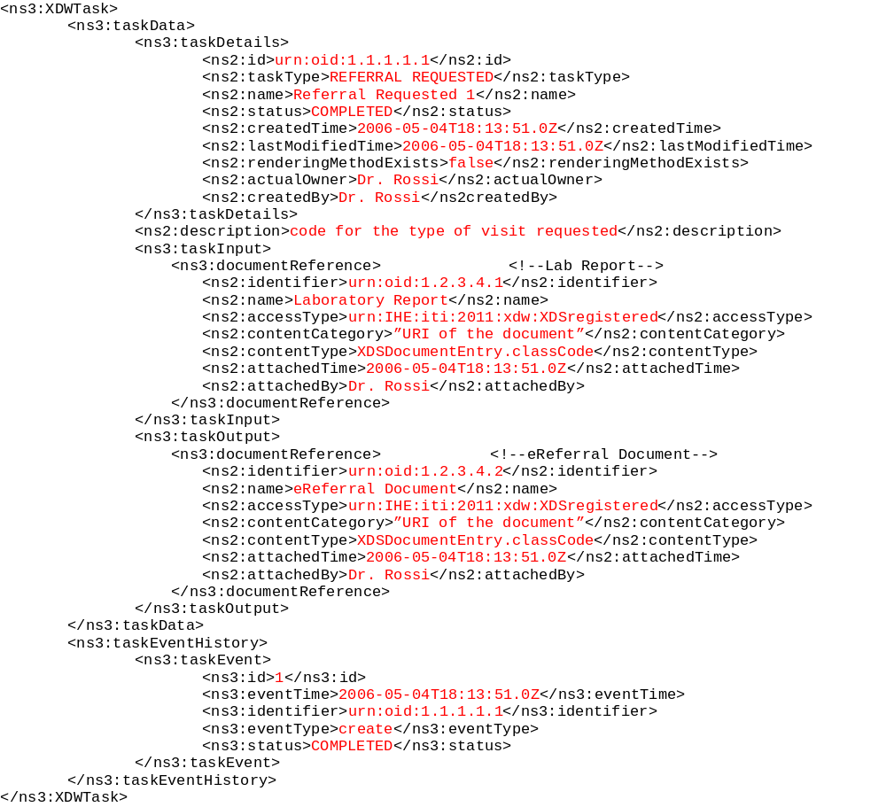

6.2.2 Task: “Referral Scheduled”

Task attributes | Rules for the task “Referral Scheduled”
Task id | Unique id of the instance of the task
Task type | Referral Scheduled
Task name | Referral Scheduled <i>
Task description | An appointment is scheduled by the Referral Scheduler choosed by the patient
Task dependencies | Ancestors: Referral Requested  Successors: Referral Scheduled, Referral Referred
Status allowed | COMPLETED: if the appointment is scheduled  EXITED: if the appointment is cancelled  FAILED: if the appointment can’t be scheduled
Status transactions | If the appointment of the patient is cancelled, it shall be a transaction of status from COMPLETED to EXITED.
  Initial Status | Final Status | eventType
  none | COMPLETED | create
  none | FAILED | fail
  COMPLETED | EXITED | release
Input | - Required  - eReferral document
Output | None
Owner | Referral Scheduler or Workflow Monitor
owner changes | Yes, in case of cancellation of the appointment
<taskEvent> | Only One if the appointment isn’t cancelled, two in the opposite situation
Task Removal allowed | No
Task duplication | Yes

6.2.2.1 Encoding Example of XDW Task: Referral Scheduled

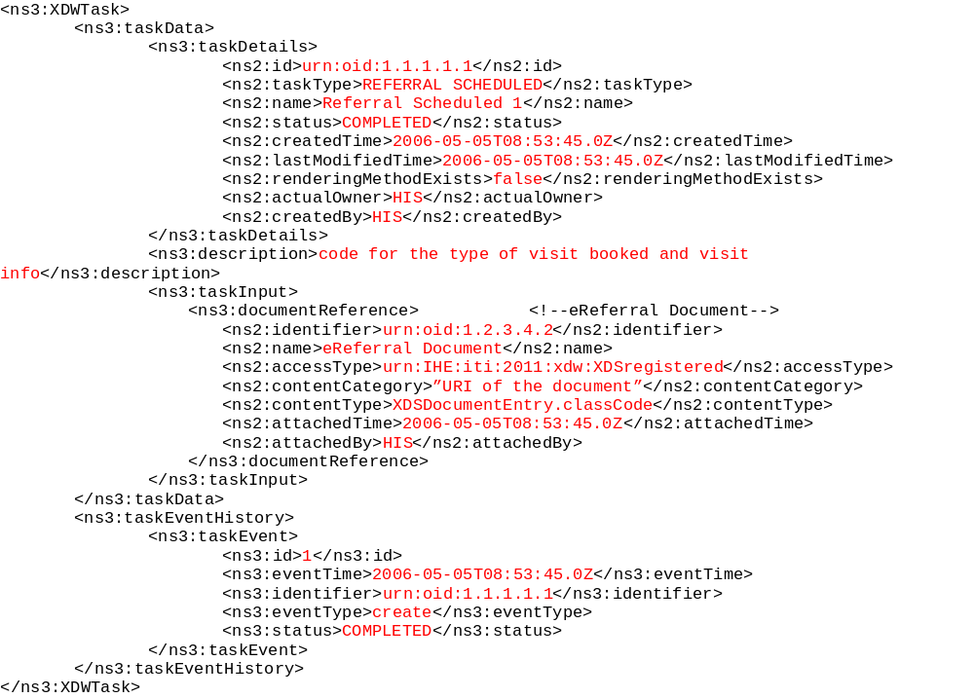
6.2.3 Task: “Referral Referred”

Task attributes | Rules for the task “Referral Referred”
Task id | Unique id of the instance of the task
Task type | Referral Referred
Task name | Referral Referred
Task description | A specialistic consultation is started and performed by the Referral Performer
Task dependencies | Ancestors: Referral Scheduled (in staus COMPLETED)  Successors: none
Status allowed | IN_PROGRESS: if the patient can be admitted  COMPLETED: if the visit is completed producing a Report  FAILED: if the visit can’t be completed
Status transactions | The task born IN_PROGRESS and it shall be a transaction of status into status COMPLETED when the visit is completed with a Report, or into status FAILED when the visit can’t be completed.
  Initial Status | Final Status | eventType
  none | IN_PROGRESS | create
  IN_PROGRESS | COMPLETED | complete
  none | FAILED | fail
  IN_PROGRESS | FAILED | fail
Input | - Required  - eReferral document
Output | - Required  - Clinical Report: if the visit can be completed  or  - Failure Report: if the visit can’t be completed
Owner | Referral Performer or Workflow Monitor
owner changes | no
<taskEvent> | Only one (failed): if the patient can’t be admitted in the healthcare structure  Two in the other cases
Task Removal allowed | No
Task duplication | No

6.2.3.1 Encoding Example of XDW Task: Referral Referred
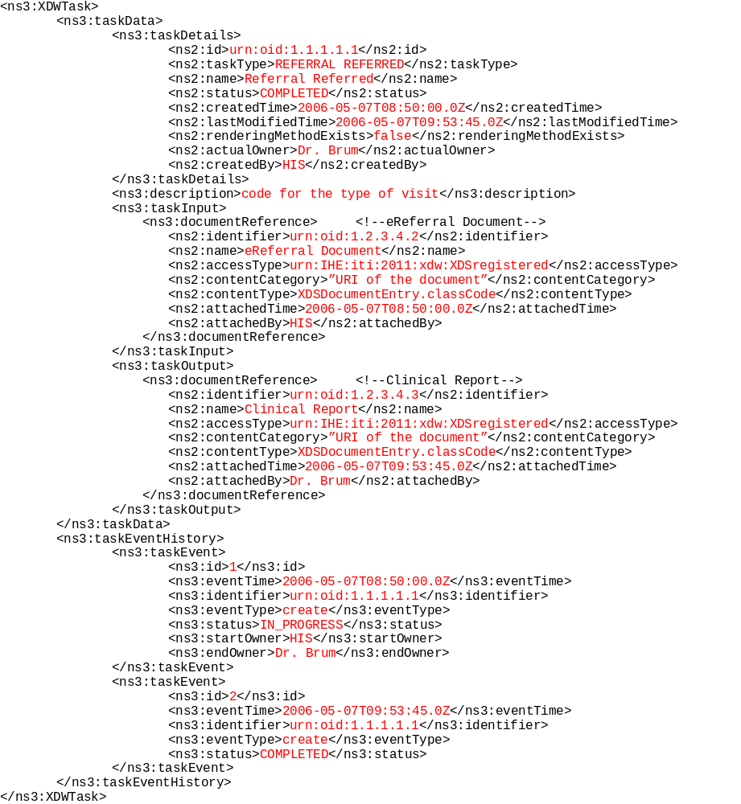

  - Transaction Flow in Support of the XBeR-WD Workflow

The following diagrams proviode an informational depiction of the combined use of the XBeR-WD Workflow Definition Profile along with the XDW Content Profile and the underlying XDS Intergation Profile.
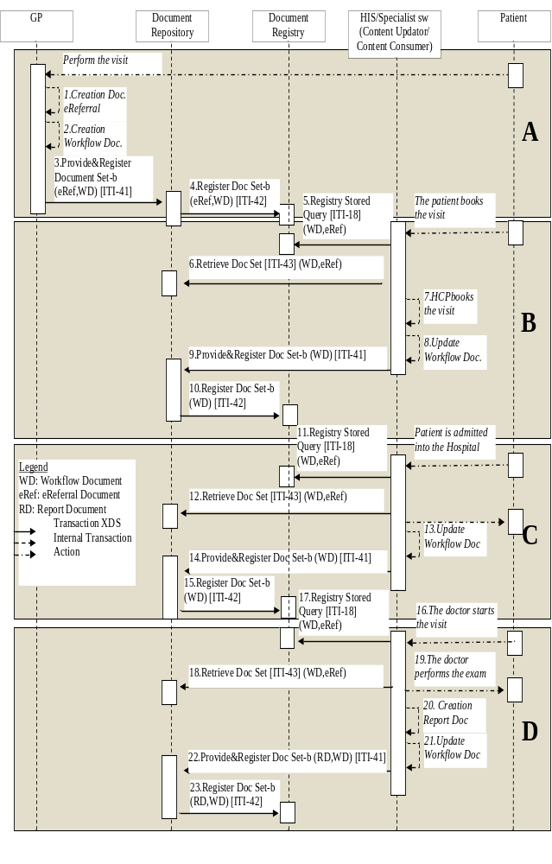
Figure 6.3-1 Transaction Diagram in XDS Environment
6.4 Technical development of WD related to the eReferral process

In this section we present more technical information related to the use-case described in the volume 1 of this profile

6.4.1 Management of the “Failing of Scheduling”
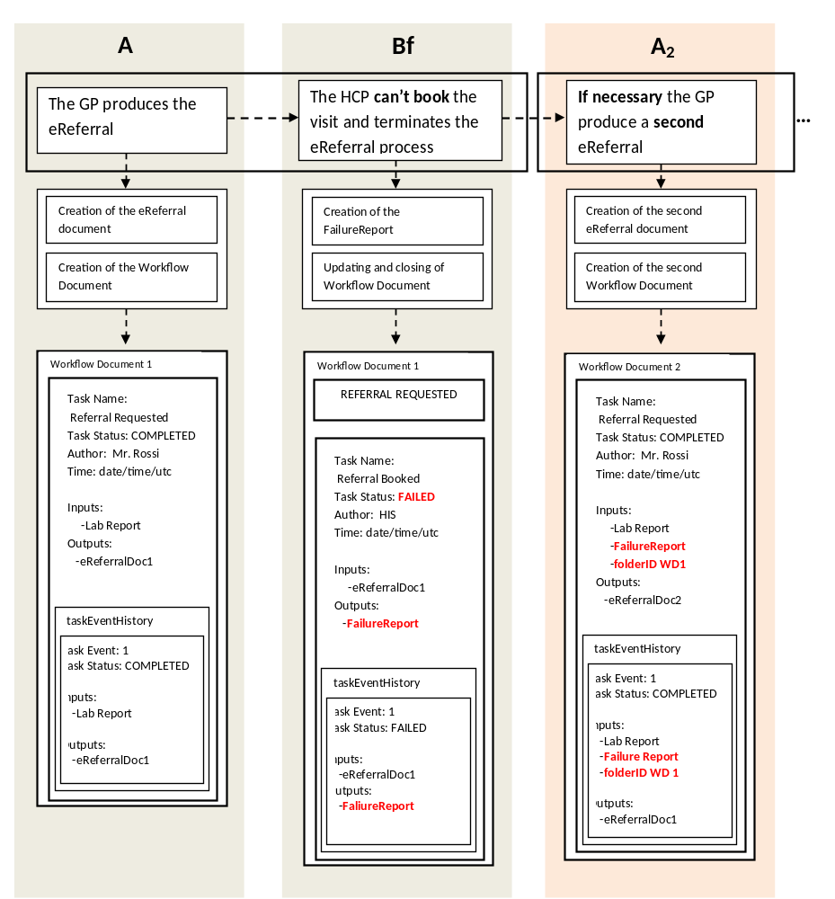Figure 6.4.1-1
Management of the workflow document: scheduling failing

6.4.2 Management of the “Failing of the reception” phase
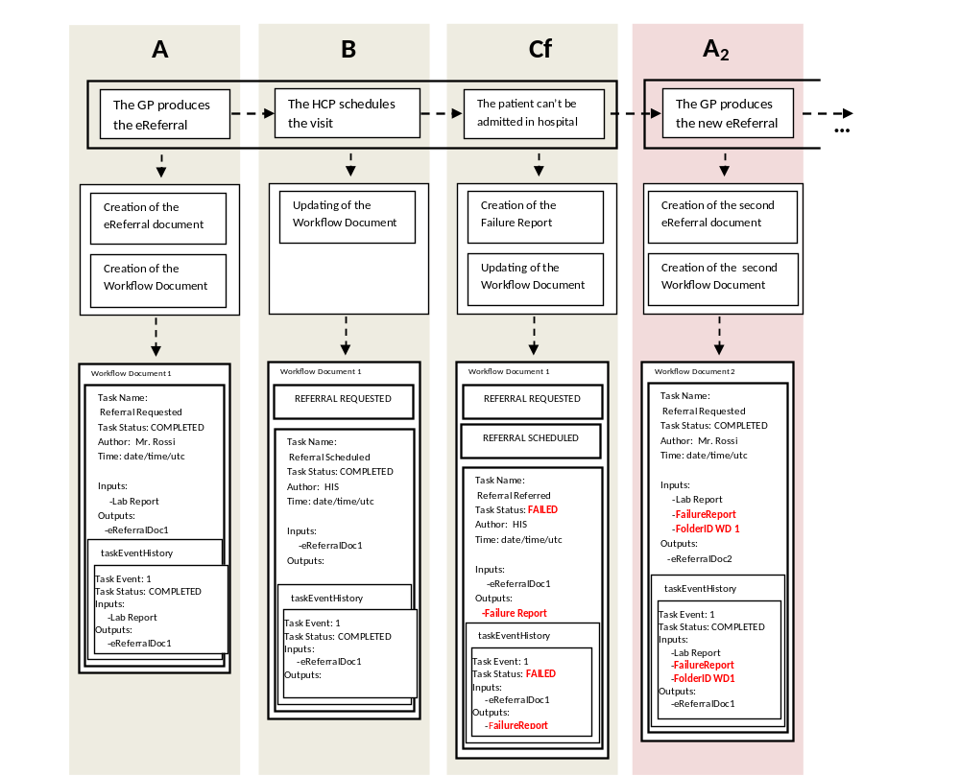 Figure 6.4.2-1
Management of the workflow document: reception failing

6.4.3 Management of the “Failing of the visit”

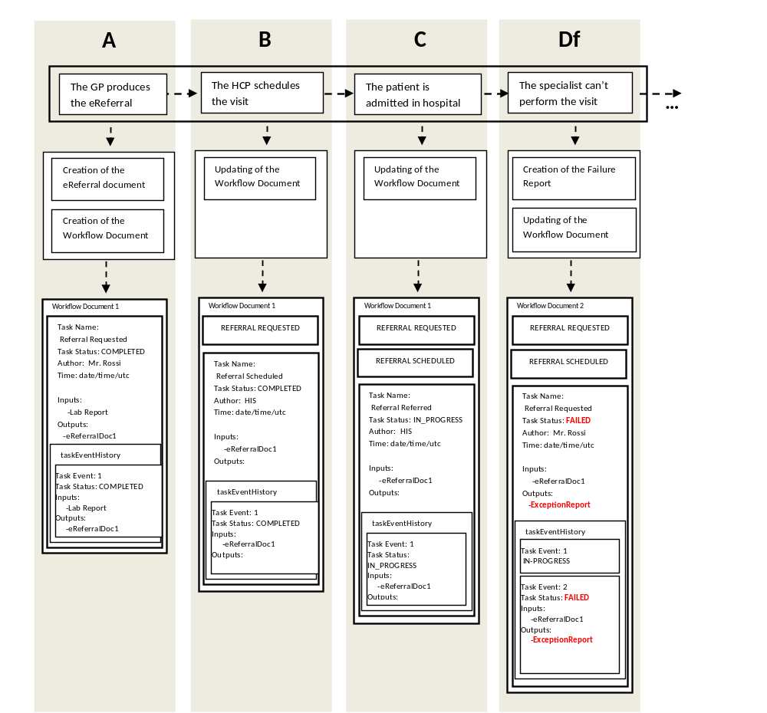 Figure 6.4.3-1
Management of the workflow document: referring failing

6.4.4 Management of the “Scheduling cancellation” phase

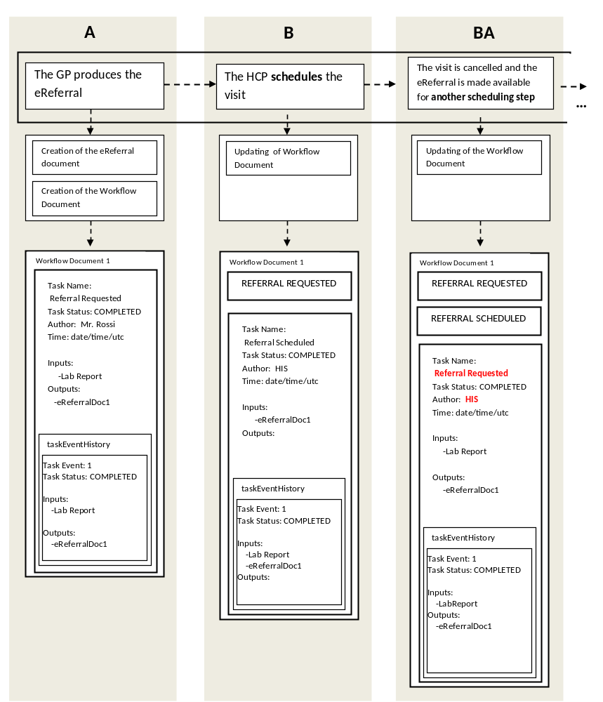 Figure 6.4.4-1
Management of the workflow document: scheduling cancellation

6.5 Input and output documents

The WS-HumanTask element that permit to store the referece of an object in input or output sections is described in IHE ITI TF-3:5.4.3
In table 6.5-1 we define the kind of document involved in the eReferral process. For each type of document this table allows to define a code (using LOINC codification) describing the type of information conveyed and expected. The owner of a task can use these codes to label the attachment, conveying this information between tasks. This code describes the function that the document performs during the evolution of the process or during the execution of the task. The same role can be played by documents characterized by different classCodes which are defined in the specific XDS Affinity Domain. This table suggests which type of format are expected for each type of document.
Document | Expected contentType | contentCategory | Expected formats | LOINC description
eReferral | code defined in the <XDSDocumentEntry.classCode> in the specific XDS AffinityDomain | 2.16.840.1.113883.6.1^57832-8 | CDA R.2 | Prescription for diagnostic or specialistic care
Clinical Report | code defined in the <XDSDocumentEntry.classCode> in the specific XDS AffinityDomain | 2.16.840.1.113883.6.1^…. | CDA R.2  DICOM  ScannedDoc | ...
Exception Report | code defined in the <XDSDocumentEntry.classCode> in the specific XDS AffinityDomain | 2.16.840.1.113883.6.1^…. | CDA R.2  ScannedDoc | ...

Table 6.5-1 Documents involved in the eReferral process

Appendix A- Complete example of eReferral Workflow Document

In this Appendix we propose a complete example of a Workflow Document related to the eReferral process as we can see it when the visit is completed succesfully.

<?xml version="1.0" encoding="UTF-8"?>
<ns3:XDW.WorkflowDocument
xmlns:ns1="urn:hl7-org:v3"
xmlns:ns2="http://docs.oasis-open.org/ns/bpel4people/ws-humantask/types/200803"
xmlns:ns3="urn:ihe:iti:2011:xdw"
xmlns:xsi="http://www.w3.org/2001/XMLSchema-instance"
xsi:schemaLocation="urn:ihe:iti:2011:xdw file:C: XDW-2011-09-13.xsd">
<ns3:id root="1.2.3.4.5"/>
<ns3:effectiveTime value="20110401031520"/>
<ns3:confidentialityCode code="1.24.3.3.3"/>
<ns3:patient>
<ns3:id root="1.3.6.1.4.1.21367.13.20.1000" extension="33333"
assigningAuthorityName="IHERED"/>
</ns3:patient>
<ns3:author>
<ns3:assignedPerson>
<ns1:name>
<ns1:family>Brum</ns1:family>
<ns1:prefix>Dr.</ns1:prefix>
</ns1:name>
</ns3:assignedPerson>
</ns3:author>
<ns3:workflowInstanceID>urn:oid:1.2.3.4</ns3:workflowInstanceID>
<ns3:workflowDocumentSequenceNumber>3</ns3:workflowDocumentSequenceNumber>
<ns3:workflowStatus>CLOSED</ns3:workflowStatus>
<ns3:workflowStatusHistory>
<ns3:documentEvent>
<ns3:eventTime>2006-05-04T18:13:51.0Z</ns2:eventTime>
<ns3:eventType>create</ns2:eventType>
<ns3:taskEventIdentifier>urn:oid:1.1.1.1.4</ns2:taskEventIdentifier>
<ns3:author>Mr. Rossi</ns2:author >
<ns3:previousStatus></ns2:previousStatus>
<ns3:actualStatus>OPEN</ns2:actualStatus>
</ns3:documentEvent>
<ns3:documentEvent>
<ns3:eventTime>2006-05-07T09:53:45.0Z</ns2:eventTime>
<ns3:eventType>complete</ns2:eventType>
<ns3:taskEventIdentifier>urn:oid:1.1.1.1.7</ns2:taskEventIdentifier>
<ns3:author>Dr. Brum</ns2:author >
<ns3:previousStatus>OPEN</ns2:previousStatus>
<ns3:actualStatus>CLOSED</ns2:actualStatus>
</ns3:documentEvent>
</ns3:workflowStatusHistory>
<ns3:workflowDefinitionReference>urn:oid:1.2.3.4.5.6.7.8.9</ns3:workflowDefinitionReference>
<ns3:TaskList>
<ns3:XDWTask>
<ns3:taskData>
<ns3:taskDetails>
<ns2:id>urn:oid:1.1.1.1.1</ns2:id>
<ns2:taskType>REFERRAL REQUESTED</ns2:taskType>
<ns2:name>Referral Requested 1</ns2:name>
<ns2:status>COMPLETED</ns2:status>
<ns2:createdTime>2006-05-04T18:13:51.0Z</ns2:createdTime>
<ns2:lastModifiedTime>2006-05-04T18:13:51.0Z</ns2:lastModifiedTime>
<ns2:renderingMethodExists>false</ns2:renderingMethodExists>
<ns2:actualOwner>Dr. Rossi</ns2:actualOwner>
<ns2:createdBy>Dr. Rossi</ns2createdBy>
</ns3:taskDetails>
<ns2:description>code for the type of visit requested</ns2:description>
<ns3:taskInput>
<ns3:documentReference> <!--Lab Report-->
<ns2:identifier>urn:oid:1.2.3.4.1</ns2:identifier>
<ns2:name>Laboratory Report</ns2:name>
<ns2:accessType>urn:IHE:iti:2011:xdw:XDSregistered</ns2:accessType>
<ns2:contentCategory>”URI of the document”</ns2:contentCategory>
<ns2:contentType>XDSDocumentEntry.classCode</ns2:contentType>
<ns2:attachedTime>2006-05-04T18:13:51.0Z</ns2:attachedTime>
<ns2:attachedBy>Dr. Rossi</ns2:attachedBy>
</ns3:documentReference>
</ns3:taskInput>
<ns3:taskOutput>
<ns3:documentReference> <!--eReferral Document-->
<ns2:identifier>urn:oid:1.2.3.4.2</ns2:identifier>
<ns2:name>eReferral Document</ns2:name>
<ns2:accessType>urn:IHE:iti:2011:xdw:XDSregistered</ns2:accessType>
<ns2:contentCategory>”URI of the document”</ns2:contentCategory>
<ns2:contentType>XDSDocumentEntry.classCode</ns2:contentType>
<ns2:attachedTime>2006-05-04T18:13:51.0Z</ns2:attachedTime>
<ns2:attachedBy>Dr. Rossi</ns2:attachedBy>
</ns3:documentReference>
</ns3:taskOutput>
</ns3:taskData>
<ns3:taskEventHistory>
<ns3:taskEvent>
<ns3:id>1</ns3:id>
<ns3:eventTime>2006-05-04T18:13:51.0Z</ns3:eventTime>
<ns3:identifier>urn:oid:1.1.1.1.1</ns3:identifier>
<ns3:eventType>create</ns3:eventType>
<ns3:status>COMPLETED</ns3:status>
</ns3:taskEvent>
</ns3:taskEventHistory>
</ns3:XDWTask>
<ns3:XDWTask>
<ns3:taskData>
<ns3:taskDetails>
<ns2:id>urn:oid:1.1.1.1.1</ns2:id>
<ns2:taskType>REFERRAL SCHEDULED</ns2:taskType>
<ns2:name>Referral Scheduled 1</ns2:name>
<ns2:status>COMPLETED</ns2:status>
<ns2:createdTime>2006-05-05T08:53:45.0Z</ns2:createdTime>
<ns2:lastModifiedTime>2006-05-05T08:53:45.0Z</ns2:lastModifiedTime>
<ns2:renderingMethodExists>false</ns2:renderingMethodExists>
<ns2:actualOwner>HIS</ns2:actualOwner>
<ns2:createdBy>HIS</ns2:createdBy>
</ns3:taskDetails>
<ns3:description>code for the type of visit booked and visit info</ns3:description>
<ns3:taskInput>
<ns3:documentReference> <!--eReferral Document-->
<ns2:identifier>urn:oid:1.2.3.4.2</ns2:identifier>
<ns2:name>eReferral Document</ns2:name>
<ns2:accessType>urn:IHE:iti:2011:xdw:XDSregistered</ns2:accessType>
<ns2:contentCategory>”URI of the document”</ns2:contentCategory>
<ns2:contentType>XDSDocumentEntry.classCode</ns2:contentType>
<ns2:attachedTime>2006-05-05T08:53:45.0Z</ns2:attachedTime>
<ns2:attachedBy>HIS</ns2:attachedBy>
</ns3:documentReference>
</ns3:taskInput>
</ns3:taskData>
<ns3:taskEventHistory>
<ns3:taskEvent>
<ns3:id>1</ns3:id>
<ns3:eventTime>2006-05-05T08:53:45.0Z</ns3:eventTime>
<ns3:identifier>urn:oid:1.1.1.1.1</ns3:identifier>
<ns3:eventType>create</ns3:eventType>
<ns3:status>COMPLETED</ns3:status>
</ns3:taskEvent>
</ns3:taskEventHistory>
</ns3:XDWTask>
<ns3:XDWTask>
<ns3:taskData>
<ns3:taskDetails>
<ns2:id>urn:oid:1.1.1.1.1</ns2:id>
<ns2:taskType>REFERRAL REFERRED</ns2:taskType>
<ns2:name>Referral Referred</ns2:name>
<ns2:status>COMPLETED</ns2:status>
<ns2:createdTime>2006-05-07T08:50:00.0Z</ns2:createdTime>
<ns2:lastModifiedTime>2006-05-07T09:53:45.0Z</ns2:lastModifiedTime>
<ns2:renderingMethodExists>false</ns2:renderingMethodExists>
<ns2:actualOwner>Dr. Brum</ns2:actualOwner>
<ns2:createdBy>HIS</ns2:createdBy>
</ns3:taskDetails>
<ns3:description>code for the type of visit</ns3:description>
<ns3:taskInput>
<ns3:documentReference> <!--eReferral Document-->
<ns2:identifier>urn:oid:1.2.3.4.2</ns2:identifier>
<ns2:name>eReferral Document</ns2:name>
<ns2:accessType>urn:IHE:iti:2011:xdw:XDSregistered</ns2:accessType>
<ns2:contentCategory>”URI of the document”</ns2:contentCategory>
<ns2:contentType>XDSDocumentEntry.classCode</ns2:contentType>
<ns2:attachedTime>2006-05-07T08:50:00.0Z</ns2:attachedTime>
<ns2:attachedBy>HIS</ns2:attachedBy>
</ns3:documentReference>
</ns3:taskInput>
<ns3:taskOutput>
<ns3:documentReference> <!--Clinical Report-->
<ns2:identifier>urn:oid:1.2.3.4.3</ns2:identifier>
<ns2:name>Clinical Report</ns2:name>
<ns2:accessType>urn:IHE:iti:2011:xdw:XDSregistered</ns2:accessType>
<ns2:contentCategory>”URI of the document”</ns2:contentCategory>
<ns2:contentType>XDSDocumentEntry.classCode</ns2:contentType>
<ns2:attachedTime>2006-05-07T09:53:45.0Z</ns2:attachedTime>
<ns2:attachedBy>Dr. Brum</ns2:attachedBy>
</ns3:documentReference>
</ns3:taskOutput>
</ns3:taskData>
<ns3:taskEventHistory>
<ns3:taskEvent>
<ns3:id>1</ns3:id>
<ns3:eventTime>2006-05-07T08:50:00.0Z</ns3:eventTime>
<ns3:identifier>urn:oid:1.1.1.1.1</ns3:identifier>
<ns3:eventType>create</ns3:eventType>
<ns3:status>IN_PROGRESS</ns3:status>
<ns3:startOwner>HIS</ns3:startOwner>
<ns3:endOwner>Dr. Brum</ns3:endOwner>
</ns3:taskEvent>
<ns3:taskEvent>
<ns3:id>2</ns3:id>
<ns3:eventTime>2006-05-07T09:53:45.0Z</ns3:eventTime>
<ns3:identifier>urn:oid:1.1.1.1.1</ns3:identifier>
<ns3:eventType>create</ns3:eventType>
<ns3:status>COMPLETED</ns3:status>
</ns3:taskEvent>
</ns3:taskEventHistory>
</ns3:XDWTask>
</ns3:TaskList>
</ns3:XDW.WorkflowDocument>

The first three documents can be located on the IHE Website at http://www.ihe.net/Technical_Framework/index.cfm#IT. The remaining documents can be obtained from their respective publishers.

